How to download GIS data:

Soil:

1. Begin by opening the USDA Web Soil Survey (<http://websoilsurvey.sc.egov.usda.gov/App/WebSoilSurvey.aspx>)
2. After zooming to the area you would like to study, you must select and Area of Interest (AOI) with the AOI tool on the Interactive Map panel. Try to keep the AOI as close to a square as possible. Note that the Web Soil Survey limits the size of AOI’s.

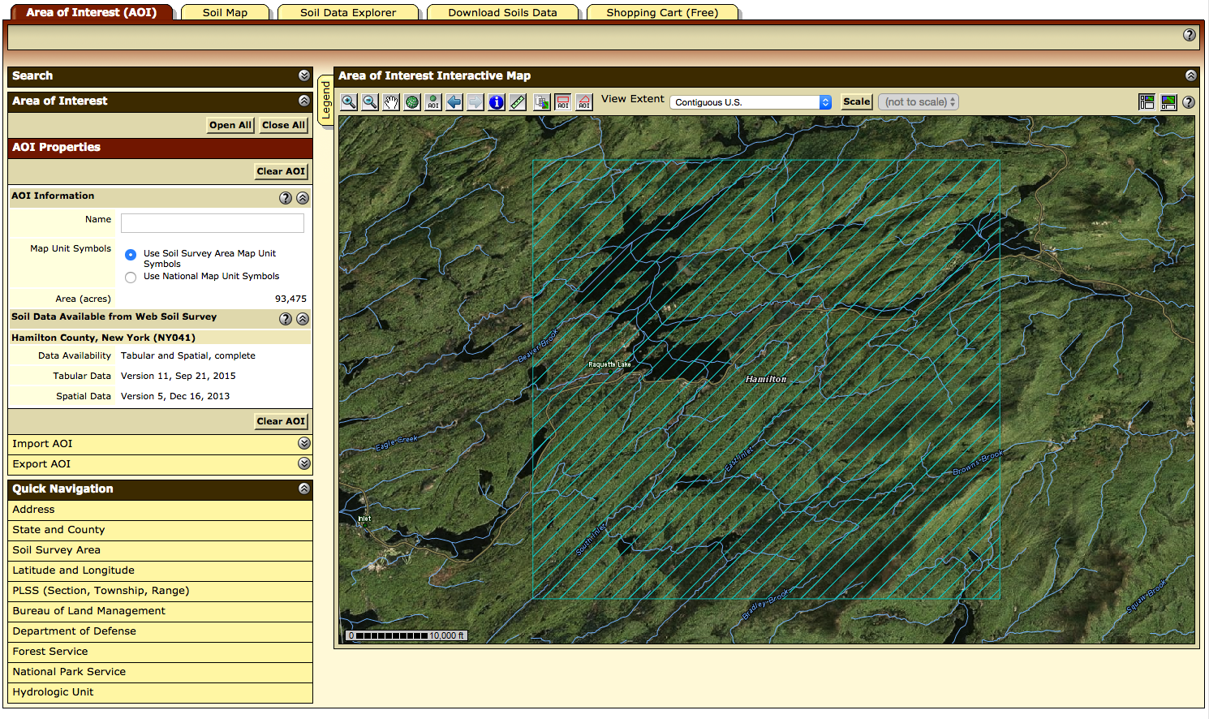

1. Once you have selected your AOI, you can go the “Download Soils Data” tab and click “Create Download Link”. Once your download link has been created, download it by clicking it. 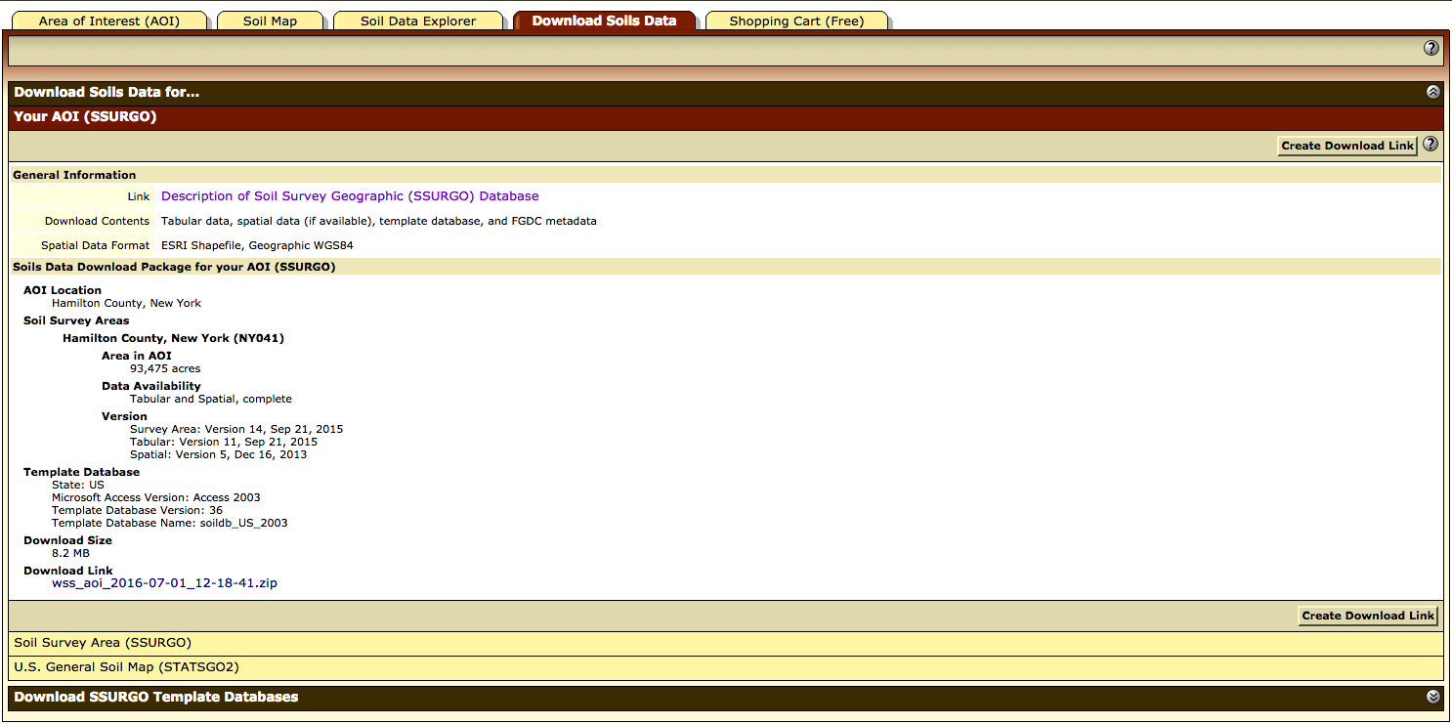

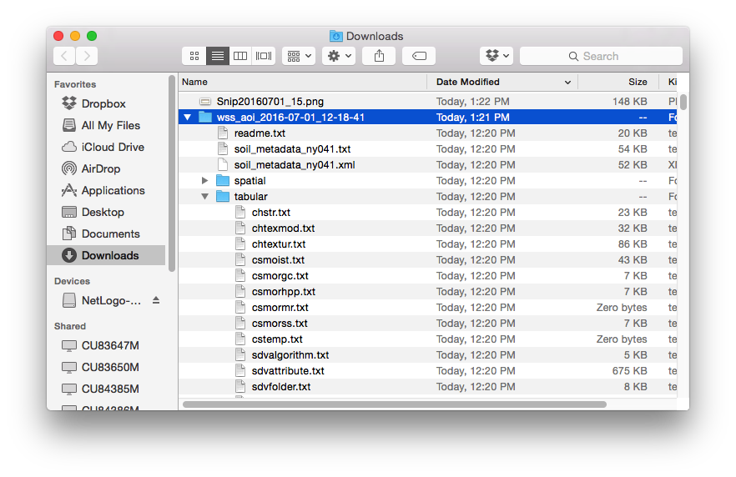

Once the file has been downloaded and unzipped, copy the “spatial” folder from the contents and paste it into the folder: simulations/*save_name*/input/soil/

1. Next, you must create the map key. Go to the Soil Properties and Qualities Tab. When you select a trait and press “View Rating”, a table with the values of that trait will appear, as well as a key to understand the symbols on the map. Now begin by creating a file in excel, or another text editor, titled “map_key.csv”:
   1. The first column of the .csv should be the map unit symbol. It is important that this is typed just as it is in the table where it is given.
   2. The second column should have the map unit name
   3. The third, fourth, and fifth columns should contain the ratings for the following traits, respectively:
      1. Soil Chemical Properties -> pH
      2. Soil Qualities and Features -> Depth to Any Soil Restrictive Layer
      3. Soil Physical Properties -> Water Content, 15 bar
   4. When completed, save the file to folder: simulations/*save_name*/input/soil

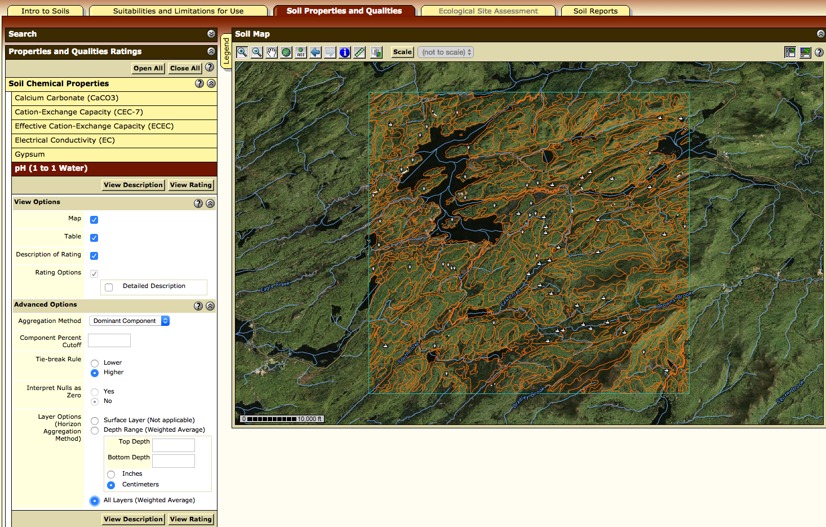

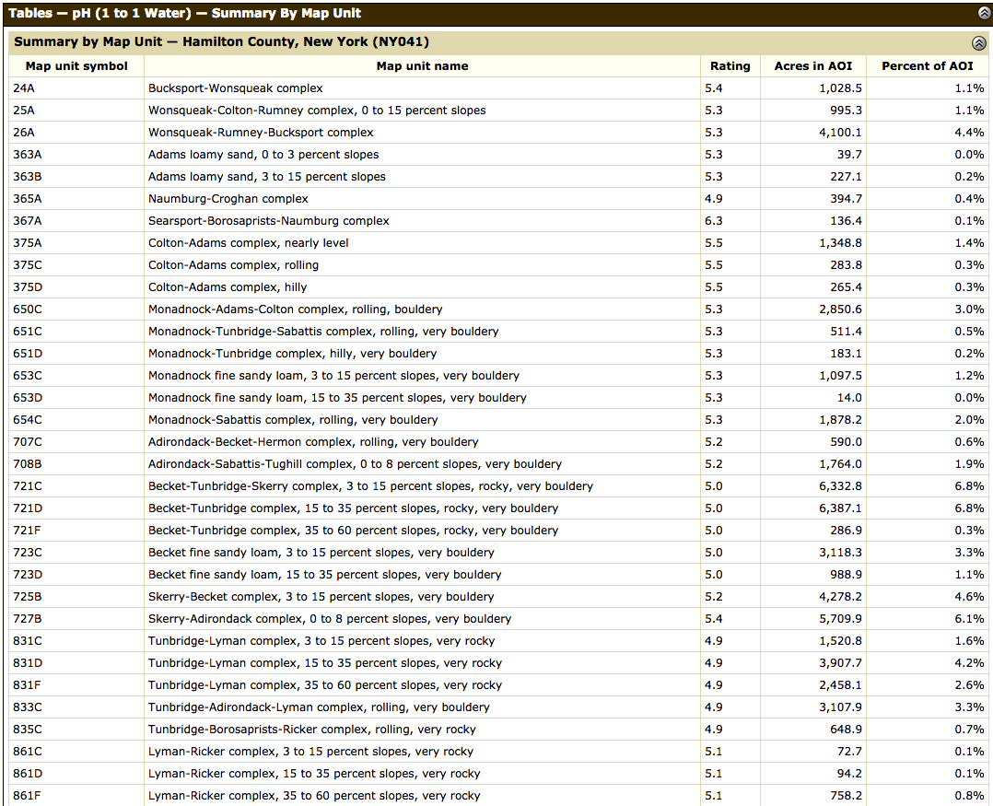

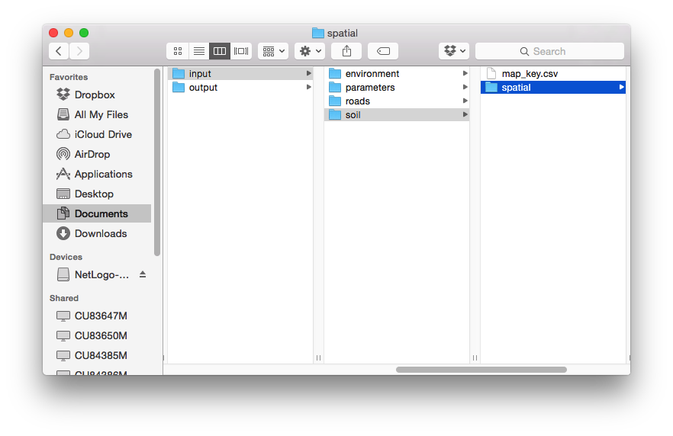

Temperature:

1. Open the PRISM climate group’s data explorer (<http://prism.nacse.org/explorer/>)

Highways:

1. <http://nationalmap.gov/small_scale/atlasftp.html?openChapters=chptrans#chptrans>
2. Transportation -> Roads, One-million Scale -> Shapefile